Excerpt from HEF discussion thread, 25 November 2015. Some links are dead but have been archived. Copies of minutes have also been saved locally.
GIRFEC Programme Board minutes: highlights and low points
Bizarrely, or more likely as a knee jerk reaction to the latest tranche of bad publicity, the Scottish Government has just published the draft minutes of the final GIRFEC Programme Board meeting (held in September 2014), along with the minutes of the first two meetings held back in 2011, neither of which were there yesterday! They all make for very interesting reading and confirm what we already knew (but a few sceptics hadn't wanted to believe).
Here are a few highlights, or low points, depending on your perspective as a highly paid rentseeker or a victim of state sanctioned data theft.
Going back to the very first meeting in February 2011 we find this SWOT analysis:
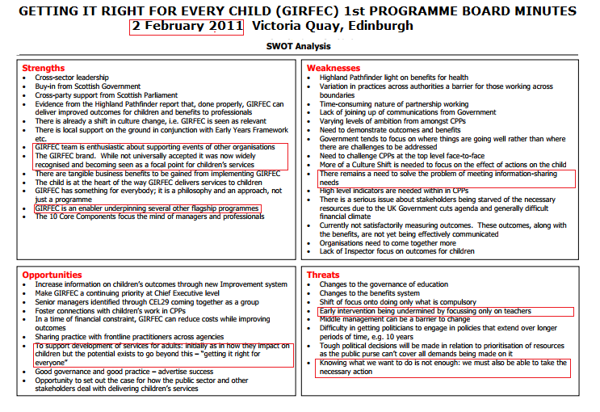
By March 2012 we see how every agency is to be expected to snoop on citizens and share personal data.
The importance of linking in with housing personnel was also raised, as they are often the only ones going into a house.

June 2012
Information Sharing
The board’s attention was brought to two emerging risks:
• Local development may lead to local information silos, meaning there may be difficulties sharing information where children cross geographical boundaries.
• Local solutions may not factor in third sector access for inclusion in secure information sharing systems.
In discussion, the board recognised that there was a legal emphasis on data protection rather than data sharing. There were two main approaches to a national electronic information sharing solution: a national database or minimum requirements for any system. Glasgow were looking at the possibility of sharing information across boundaries on looked after children using SEEMiS.
The board agreed that it gave its strongest encouragement that information sharing across boundaries and with the third sector should be included in local solutions.

Sept 2012
Consultation on Children and Young People Bill
Phil Raines gave an overview of the thinking behind the development of the proposals set out in the consultation on the Children and Young People Bill, due to close on 25 September 2012.
Points raised in discussion included:
• The tensions involved in the provision of a Named Person from age 5 for home educated children
Information Sharing: Risk to wellbeing leading to significant harm
Allan Moffat presented the paper on sharing concerns about a child’s wellbeing (GIRPB/07/07), highlighting the difficulties in sharing information where a concern is below the level of a child protection concern. The board agreed that engagement with the Scottish Information Commissioner should take place in order to open a discussion on the extent to which information could be shared without consent if there was a concern that there was a risk or potential risk to wellbeing.

Nov 2012
• There was a suggestion that we need to do more to “take the community with us”. Families, carers and children were not, it was said, switched on to GIRFEC. Boyd McAdam pointed out that it had been a conscious decision to focus first on embedding GIRFEC in the professional practice of all stakeholder delivery bodies, before raising awareness in the general public
• There was a need for a coherent and united national message on GIRFEC and how other areas knitted together. Messages even at
Ministerial level could do more to make clear that GIRFEC is the overarching programme.
In other words, deliberate concealment until it was too late. That chimes with recent third sector workshop sessions we have heard about in the south of Scotland where participants were told that the public really didn't need to know any of the detail as they might be confused. Even more worrying for our informant was when it was mentioned that the children were just the start of GIRFEC being rolled out to all citizens and community (but we already knew that). Seamless family planning and community planning 'partnerships' to make sure we all 'do it right' in an appropriate state approved manner. Infantilising the population and appointing a monitor class to report any dissent = sorted!
Information Commissioner’s Office (ICO)
Martin Crewe gave a verbal update. There had been a good meeting on 23 November 2012 with Ken MacDonald, some Board members, GIRFEC officials and information specialists. Discussion centred on the requirements of the Data Protection Act and ICO stressed neither the Act or ICO - should be seen as a barrier. Information about children should be shared appropriately when justified, but the rationale for doing so should be also be documented.
Actions:
1. GIRFEC team to produce statement to encourage shift and Alan Small information shift : ICO to endorse this.
2. Joint work between ICO and GIRFEC on consent guidance including Alan Small examples to give reassurance on this.
It’s important that these messages are widely received/

Feb 2013
Allan Moffat asked Jane about information sharing. Jane said they used clear direction and intent, and were introducing a single approach. The work was being piloted.
Jane highlighted issues with GPs, due to their structures and contracts. In comparison they had very good relationships with the police. The Minister was keen that more work with GPs was done to break the barriers.
Carol Kirk said working with Housing was very productive as they had access to information and were supportive. Housing officers could identify long-term, low level neglect. Sharon made the point that people were still trying to get used to working together.
Boyd updated the Board on (GIRPB/09/08), the issues around sharing information without consent.
A joint statement has been agreed with the Information Commissioner’s Office which should help clarify situations where a child was on a pathway to risk to wellbeing as well as significant risk of harm. The statement should free up the way practitioners share information under existing law. However there were concerns on how best to disseminate the message in a way that did not produce an adverse reaction for stakeholders.

April 2013
Risk and Issue Register
Pauline gave an update on the paper to the Board (GIRPB/10/04/a and GIRPB/10/04/b). She added that no feedback had been received and talked through the Risks as follows:
• Risks 1 & 2 remained at 12, but action was being taken;
• Risk 3 was reduced due to the debate in Parliament; refocus
of the Board; and the aim of the Working Groups;
• The other three Risks remained as they were;
• It was noted that Information Sharing was still Red.

That sounds a bit of a 'concern'.
Information Sharing Alan Small
Alan gave the Board an update on information sharing (GIRPB/10/07). He said that as an action from the last meeting, there
were concerns that the current threshold being used was too high and didn’t fit with early intervention. Advice from the ICO was tested with health partners and a statement on information sharing from the Information Commissioner’s Office was published on 8 April.
Andrew Sutherland added that this was very positive but that some bodies will be more risk averse than others. The Minister said that this was the first step to build upon and asked if there were any other points. Further points were made:
• Ralph Roberts mentioned dissemination and that there were a lot of messages from GP’s. Bob Fraser added that the Royal College had the final version of the statement but that they were still considering it within Scotland. The British Medical Association was still to consult with the General Medical Council
• The Minister added that we needed to figure out how to manage anxieties from some of the professions. Alan Small added a further report on reactions would be brought to the next meeting of the Board.

Sept 2013
National Parent Forum Scotland (NPFS)
The National Parent Forum fully supported the principles of GIRFEC. They see their role as disseminating information on GIRFEC to parents and representing their concerns to the Programme Board. Iain Ellis noted that it was hard to find parents who were making negative comments about the Named Person as those heard from pressure groups. The NPFS were keen to be more involved with the Board in future to develop these messages.
The NPFS believed that for GIRFEC implementation to succeed and prosper, parents and the wider public needed to be brought on board and that this should be addressed as a matter of urgency. They offered help in achieving this.
As we know, the NPFS, allegedly "set up to give Parent Councils and Parents an opportunity to discuss and raise educational issues of mutual interest or concerns at a national level" is just a government funded mouthpiece to channel propaganda.
Children and Young People (Scotland) Bill
The main current issues were the Named Person, with concerns expressed in relation to parental rights, privacy and information sharing and resources. The Minister reaffirmed the policy and indicated that a strong narrative was required around the Named Person.
Alan Small presented paper GIRPB/11/04. Concerns around the information sharing duties in Part 26 and 27 of the Bill had been expressed. He reiterated the following ICO advice:
• For the role of the Named Person to be effective, appropriate information sharing was required
• The need to move the threshold beyond child protection to take in concerns of child wellbeing, which should trigger effective and proportionate early intervention
• The ICO statement should be crucial in managing concern and in changing the culture of information exchange.
Alan offered an example of good practice on information sharing from Fife. Fife already had the Named Person in place and the police had been sharing information since April 2013. 400 cases per month had been raised. Teachers stated that they had not seen any increase in their workload and that there had not been any adverse comments from parents.
Here is the same Alan on the BBC responding Kaye Adams' question: Can you hang up the phone on a Named Person?
Feb 2014
Update on the Children and Young People Bill
The Minister told the Board a majority had passed the Bill on 19 February, with no ‘No’ votes recorded. The Bill was now due to receive Royal Assent. She mentioned the difficulties encountered at Stages 2 and 3. AS said there had been criticism over the information sharing provisions within the Named Person role, and discussions around concerns about the provision being too wide. This was amended to say that information should be shared if it ought to be shared. It also now stresses the importance of taking account of the children’s views.
The Minister said ongoing media coverage on information sharing and the Named Person raised issues of understanding and perception. She thanked all stakeholders again for their support and stressed the need for consistent messaging.

#Pinocchio
BM mentioned how CfE had been supported by a clear and focussed programme of engagement with parents. She suggested a light-touch guidance at establishment level could be developed, and encouraged through messages. She asked the Board if this was a role for the National Implementation Support Group (NISG) or for Education Scotland. AD added that core material was available and that Education Scotland could encourage its use at parent’s evenings through the ADES and NPFS networks. The Minister added there was evidence from enquiries from constituents that clearer messages were needed.

#Pinocchio
Risk Register
PD gave a short update to the Board on the Risk Register (GIRPB/12/05). The key updates were that the Bill had been passed, and that Named Person and information-sharing issues were still sensitive, and had been marked as such in the Risk Register. The Register was not for further sharing.

May 2014
MC (Martin Crewe) added that we needed to move from a permissive to directive approach on information sharing, as there was no national system to implement information sharing we needed to make sure individual systems were compatible

And finally Sept 2014 (draft)
MG spoke to three aspects of Information Sharing that require consideration:
Policy/Legal, Cultural and Technical.
PD advised that Alan Small is leading on IS work and PR explained that table-top exercises are being organised to practise working through IS issues from start to finish. He sees the three main components as being:
• Picking up information – i.e. identifying information relevant to wellbeing
• Sending information – transferring data securely to the appropriate people
• Receiving information – mechanisms for securely receiving, storing and accessing data
The Minister spoke to the progress being made in Ayrshire, in terms of information sharing systems. PD said that while the approach in Ayrshire through Ayrshare is not suitable for every organisation, it could still prove useful as a learning tool.
Implementation Update
Glasgow City is working on Information Sharing processes using the new SEEMIS developments. The GIRFEC SEEMIS project should allow other areas to participate in these developments. ADES will take a leading role in this work.

And we all know about SEEMiS.
It's also worth reiterating that the ICO statement on which the Snooperati rely (and which we now know was written by the GIRFEC Board and rubber stamped by the ICO's Scottish branch office) has never been subject to proper legal scrutiny and would not stand up in other parts of the UK, despite the Data Protection Act being UK wide and any amendment thereof reserved to Westminster.
UPDATE: Manx citizens have better protection under the same UK wide Data Protection Act than their Scots counterparts. Now why would that be the case? This question, and others, need to be asked until we get some proper answers.

