Home educators' experiences of the health visiting service in Scotland

Survey Report
June 2019

Scottish Home Education Forum
www.scothomeed.co.uk

Introduction

The Scottish Home Education Forum (founded in 1999) is a national support network which offers information, peer support and advocacy to home educating families and those considering the option, as well as conducting research and campaigning on home education and allied issues.
In common with other grass-roots groups, the forum receives no public funding and is facilitated by volunteers, who, between them, have decades of home educating experience. Collectively, they undertake necessary work that has been left undone by funded bodies, most of whom not only lack awareness and understanding of our diverse and vibrant community, but often appear unwilling to close an ever-widening knowledge and skills gap, thereby exacerbating an unacceptably exclusionary approach by policy-makers and practitioners alike.
We remain concerned about widespread misinformation and prejudice across services and the amplification of problems through repeated misuse of language (e.g. ‘home- schooling’) and misrepresentation or misapplication of the law pertaining to home education. As acknowledged experts in this area, we have repeatedly brought these matters to the attention of public sector agencies and the Scottish Government, and received assurances last year that they will be addressed through mandatory training for professionals in co-operation with home educators, although this has not been actioned to date.

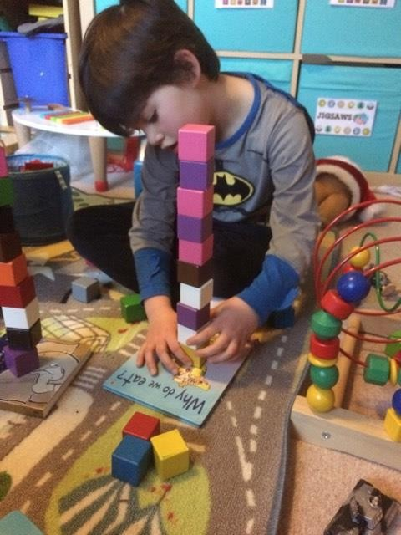
Home education
There are no reliable statistics on the number of school- age children who are in home education in Scotland, since schooling is an opt-in service and it is parents, not the state, who are responsible in law for providing suitable education for their own children during the compulsory years.
Contrary to popular belief, elective home education or ‘education by other means’ (often erroneously referred to as ‘homeschooling’) has equal status in law to council schooling in Scotland and is in fact the default model, requiring no permission, registration or notification. Local authority consent is only required (and may not be unreasonably withheld) for the withdrawal of
a school-age child from a state (not private) school s/he has attended on one occasion or more, with several exceptions that are (non-exhaustively) outlined in statutory guidance.
Local authorities are required to adhere to primary legislation (which underscores parental choice and affords none to children and young people, school-going or otherwise, despite the ‘rights respecting’ rhetoric) and statutory guidance, (which must be read to comply with the overarching human rights and data protection framework);

yet parents frequently encounter public servants, including health professionals, who seek to mislead them about their legal rights and responsibilities, deliberately or otherwise. This has created a culture of mistrust, and relationships between families and services have at times deteriorated to the point of complete breakdown, as evidenced by numerous forum discussions.
Historically, home educating families in Scotland have tended to be evenly split between those who have proactively chosen to home educate from the outset and those who have withdrawn their children from school, mostly due to bullying or unmet additional support needs. Over the past several years, however, there has been a perceptible shift as interest in home education has increased significantly, and support networks across Scotland have all reported a surge in membership.
Our ‘Reasons for Home Education’ report, published in March 2018, found that the increase in home educating numbers was predominantly being driven by families whose children have disabilities, chronic conditions and other additional support needs, including severe school anxiety. Many cannot be met by mainstream or special school education and have in fact been adversely impacted by the outcomes-driven (as opposed to rights-based) GIRFEC policy.

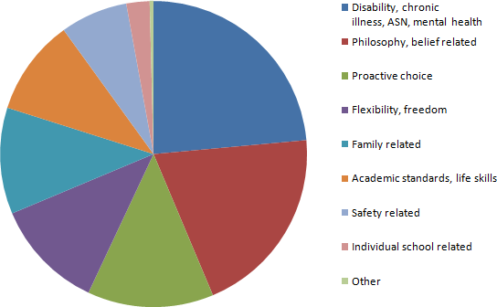

Our research
The Scottish Home Education Forum invited home educators to share their experiences of the health visiting service in Scotland after observing a steady increase in members’ reporting of concerns about engagements with health visitors, both via direct enquiries and in our members’ forum. These concerns, which were also being raised in local groups, predominantly focused on the quality and accuracy of information and advice offered in relation to childcare, nursery and school options for children, and the lack of openness regarding the voluntary nature of the heath visiting service.

A 2017 article by one of our forum administrators, Health visitors are not compulsory
– just like schools, nurseries and, allegedly, named persons, had already attracted a significant number of enquiries from parents, including non-home educators and those outside Scotland, who were dissatisfied with the service they had received, and it was clear that there were ongoing issues around the quality of information and advice offered by some health visitors.
We therefore felt a members’ survey would be informative, not only for members of our own network but also for the Nursing and Midwifery Council (NMC), Royal College of Nursing (RCN), NHS Scotland, MSPs and the Scottish Government, since its Getting It Right For Every Child (GIRFEC) policy relies heavily on health visitors to gather and share information on children and their family members, and assess any ‘wellbeing’ risks – in the absence of a precise definition or threshold test - without necessarily obtaining prior informed consent.
It is also worth noting here that the Scottish Home Education Forum is currently co- petitioning the Scottish Parliament along with Tymes Trust for a public inquiry into the human rights impact (past and present) of GIRFEC, since the universal, non- consensual data sharing at its core was struck down by the Supreme Court in 2016, yet remains embedded in public and third sector policy and guidance, thereby creating confusion among practitioners, ongoing harm to families and a breakdown in their trust in services. The petition has been referred for consideration by the Education and Skills Committee whose Members have been furnished with a number of case studies drawn from the co-petitioners’ respective networks, including examples of adverse experiences of health visiting services.
Our research in this particular area is essentially niche, given that the term ‘home education’ (or ‘elective home education’) applies to families whose children have attained compulsory education age (frequently misrepresented as compulsory school age) which commences on the August intake date following the child’s fifth birthday. School attendance is not mandatory and it is up to parents to decide whether or not to delegate their legal duty to a local authority or an independent school. Likewise, nursery education is not compulsory and many prospective home educating parents join our network well in advance of their children attaining compulsory age in order to obtain independent information and access local support networks.
Prior to conducting our survey, we had increasingly been hearing from parents misinformed by health visitors as to the nature of their service, which had frequently been misrepresented as compulsory, thus contravening the NMC professional code of practice. Parents who opt not to use nursery or council school provision had also reported that they were being routinely misled about education law, which clearly lies outwith the professional competence of health visitors wielding SHANARRI ‘wellbeing’ assessment tools. Moreover, even where complaints had been upheld and apologies issued, the cycle of misinformation, prejudice, poor advice, misuse of data, bullying behaviour and malicious referrals simply continued because ‘home-eduphobia’ is endemic and educational diversity training is inadequate or non-existent.

The following examples are typical of concerns and comments shared by our members, while others are referenced in some of the case studies we recently submitted to the Education & Skills Committee:
Has anyone had problems with health visitors when they say no to nursery, especially for children with additional needs? We feel like we are being treated unfairly because of our decision to home educate and already seeking legal advice. Just wondering if others had experienced this prejudice in the Highlands (children nearly 4 and 2).
She [health visitor] has decided to make a bogus safeguarding issue and involve social services. I believe it’s possibly her prejudice towards us home educating that is fuelling it. The GP has said it's unfair the added stress she is putting us under. We already have a lot of stress with our youngest as he has complex issues.
My GP is fine with our plans but I very recently met my new HV who looked at me as if I had horns because we weren’t doing nursery. Then the horns must have started sprouting baby horns when I mentioned our plans to home educate into primary. She was completely clueless and couldn’t get her head around us not being ‘registered’ on any council education records.
Our decision as parents to opt out of the HV service and to home educate are not child protection issues. Making non-mainstream decisions or opting out of non-compulsory services should not be red flags.
Received this from the health visitor after I said that we were home educating until such times as we think our 5-year-old boy is ready for a class room situation, if at all...
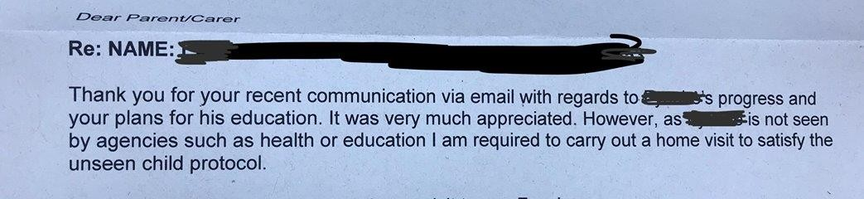

There is of course no such ‘requirement’ unless the child protection threshold is met, and the UK Supreme Court affirmed in 2016 that no adverse consequences should result from declining a voluntary service/advice below that threshold.

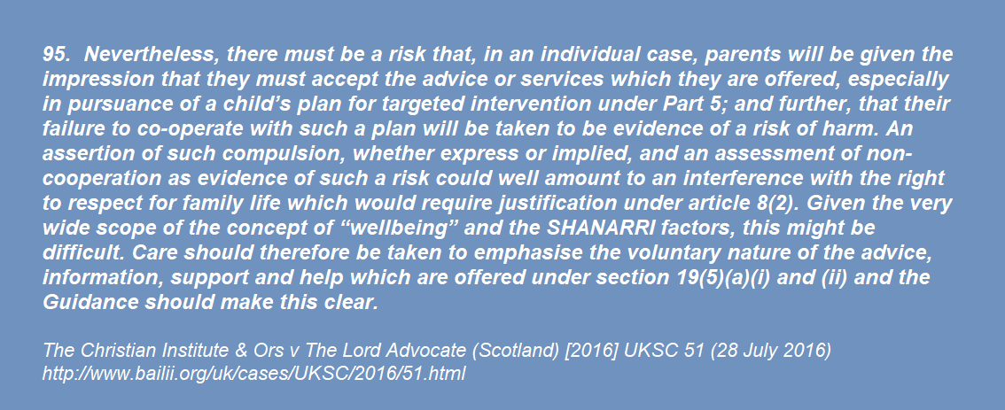

Disappointingly, current ‘protocol’ is still not reflecting this now non-negotiable ‘requirement’ of practitioners.
My old health visitor was determined to get my son registered at school and she kept the pressure up. I almost gave in to her, but so glad I did not. They can be bullying.
After opting out of this supposedly optional service, we received a letter saying "I know you have previously opted out but I would like to visit you at your home. If you could get in touch to arrange a date and time...". So we called and reiterated our choice, but the message was not passed on. They then looked at records from a previous health visitor who had acted unprofessionally (leading to us to opting out) and put in a referral to the children’s reporter. The previous health visitor’s negative opinions (of our lawful parenting choices) are effectively following us.
My daughter is 5 and would be due to start school in August. I have informed her health visitor that she will not be attending, but the health has set up a meeting with the school (that she won’t be attending!) and is calling me every day as it ‘would be in my daughters best interest if this meeting went ahead’, She has said if I don't comply it would be classed as neglect and she would have to inform social services.

Socio-economic bias has also been evident:
Staying in Govan, I felt we were being treated differently to when we lived in an area with a higher average income.
I’m in Easterhouse and have no doubt I’m being targeted because of my postcode. But why would I want to send my kids to local schools that not only have low expectations but are dangerous?
They all follow the GIRFEC tick box matrix, socioeconomic discrimination is written into it and we have been treated really badly compared to home educating friends in ‘better’ areas.

Since our members’ concerns seemed to be increasing in number and complexity, we wanted to ascertain the prevalence of problematic practices and prejudices among health visitors engaging with our community.
An informal multiple-choice poll of our members was supplemented by a more formal ‘smart survey’. Responses were invited from the subset of parents who were currently or formerly home educating, or were planning to home educate in Scotland, and who had recent experience of health visiting services.
We also conducted a small number of interviews with participants who wished to share their experiences of the heath visitor service in greater depth, as well as inviting views from a currently-practising health visitor who is a longstanding home educator and forum member.
In addition, we have referenced affidavit evidence cited by counsel in the Supreme Court ‘named person’ case that outlines the experience of one of our members, herself legally qualified. She had complained of malpractice by her health visitor and her superiors, and later received an apology and assurances that ‘lessons had been learned’; yet parents in her area have continued to report the same problematic conduct by the same health visiting team, which still appears to be widespread across

all area health boards in Scotland, as evidenced by FOI responses and parents’ subject access requests (SARs).

Members-only poll

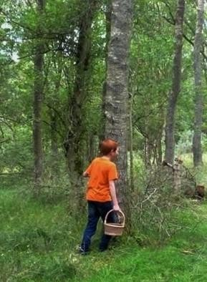

Our initial multiple-choice poll was posted in our members-only online forum in order to obtain a broad overview of ‘the experiences that home educators (and those planning to home educate) have had with health visitors, with particular reference to the (mis)representation of the nature of their service and the reliability (or otherwise) of their education-related 'advice'.’ The poll options were informed by forum discussions on the subject and attracted responses from 78 parents, many of whom added commentary.
Only four parents (5%) expressed satisfaction with their health visitor service, although many others’ experiences varied according to their allocated visitor,

suggesting there are wide inconsistencies across the profession. Members’ comments, posted on the forum and sent privately, were mixed, with examples of excellent practice described along with some less than satisfactory experiences.
I ditched as soon as I found out was wasn’t compulsory.
Four of the HVs I have had have been the most clued up professionals I have dealt with over home education, but I think any professional who deals with home educators should have a rudimentary grasp of the law. I had eight HVs and only one was a disaster.
I had a visit from my health visitor today who turned out to be lovely and actually very supportive of our choice to home education our daughter.
My HV phoned me to arrange a “weaning chat” for my second child. I said that this was not required. Within one hour, she was on my doorstep with a Post Natal Depression questionnaire that she “forgot” I had to complete. I should have known that this would be beginning of trouble!
Big problem is that when professionals see something they don't understand - they will contact the Health Visitor to voice their concerns. So many families have been reported for their children having ASD behaviour and organisations who are supposed to be the 'experts' aren’t able to be back up.
We were pressured at accept a home visit. I can't remember the details but they said it is compulsory and they will have to refer us to SS if we don't accept. Eventually we accepted one visit, one room, mum and baby only. Toddlers stayed with dad upstairs.
I’m super happy that my health visitors have always been great. Useful? Not really. But nice to be around, not pushy, polite, not nosey, however would be nice if they came around the house and help do dishes or laundry- something useful.

Nearly two-thirds of respondents (64%) believed that health visitors should have mandatory training in the law and guidance relating to home education.
GIRFEC has made things 10 times worse as these people are not qualified to comment on parenting approaches and educational choices outside their own limited area of expertise.
They just tick boxes and fill in assessments according to their own judgmental opinions of families’ choices. They have no respect for parents who choose to look after their own children, especially when they have ASNs.
Training is needed in what used to be called anti-discriminatory practice so they can reflect on and address their own prejudices.
Misinformation is more common than not, but ignorance and arrogance are a deadly combination for home educating families and those with less conventional lifestyles.
Dedicated training should be mandatory for health visitors and all other professionals who come into contact with home educating families.

Twelve parents (15%) had declined home visits by their health visitor and 23 (29%) had opted out of the service entirely, while 23 (including eight of those who had formally opted-out) reported being pressurised into accepting visits by various means, including ‘door-stepping’ and misrepresentation of their role ‘to the point of blatant lying’.
Twenty-seven parents (34%) said that they had had to correct their health visitor’s erroneous belief that nursery and school registration/attendance is ‘compulsory’, and 14% reported being misled as to their lawful options, including the relevant date of attainment of compulsory education age.
I'm very passionate about home educating and didn't think there would be so many obstacles. It seems to have all started because I told the health visitor I didn't want to see her any more.
My HV seemed alright, not particularly helpful but chatty and never had a problem with her. Then I started talking about home educating my 4-year old and she was livid, she started telling me it's illegal and I'll need to write a load of applications, have regular home visits and follow the curriculum. I told her thanks for the concern but I didn't feel I needed to see her anymore. Now I have the social work coming up this week for a 'chat'.
She said it was compulsory with no opt-out as she was also the named person. She even quoted John Swinney (who I know got it wrong!) I argued the point, but felt bullied into submission by this brainwashed person. Luckily, I had home ed groups for support but it was stressful.

12% of respondents said health visitors had implied that non-participation in nursery and/or school education would be considered a child welfare issue, despite this contravening both the law and the NMC code.
Health visitor pressurised us to send our child to nursery and made suggestions about medical treatment that only a doctor should make. Then she joined with other professionals to bully us.
I had a 'tiff' with my health visitor over her misinformation and told her I no longer wished to see her. I've subsequently had social work out for an assessment. He claims the health visitor’s referral wasn't the only concern, but refused to name any others and it was focused on my plans to home educate.

17% were concerned that their families’ personal data had been gathered and shared without their informed consent, one reporting that the health visitor had ticked the information-sharing consent box without asking. Five (6.5%) had found (via subject access requests) that their health visitors had recorded inaccurate/fabricated information and unsubstantiated opinions about their parenting choices, most of which would follow them despite requesting amendment or deletion under GDPR.
Eight forum members (10%) had felt the need to seek independent advice from peer support networks, the CAB or lawyers to stand up to their health visitors and 12 (15%) had complained about poor practice, with two parents later receiving apologies.
I've only ever met one decent and helpful health visitor. The rest were very contentious, judgemental, opinionated and not clued up on home education. Our old HV called up my husband last week to ask about our youngest going to school, he said we home ed, and we were just fine. The conversation was brief as they know how much hassle and upset they've caused over the years. They backed off big time when I threatened legal action

‘Smart’ survey

In addition to our members-only poll, we conducted a more formal online ‘smart’ survey, Home educating parents' experiences of the health visiting service in Scotland, with similar questions, which was open to other eligible respondents. It was completed by 37 individuals and partially completed by a further 21, with many participants providing detailed commentary on their responses.
73% of respondents were home educating parents (including those of under-fives), 22% were planning to home educate and 5% were former home educators.
27% had children between 0 and 2 years, 30% had 3 or 4-year-olds, and 84% had children aged 5 and over.
We asked parents how satisfied they were with their health visitor services. Only 8% said they were very satisfied, 8% said they were generally satisfied, 14% were generally dissatisfied and 38% very dissatisfied. 32% expressed neutrality and the comments reflected parents’ mixed experiences.
She knows a lot about heath and I trust her in that matter, but knows nothing about home education, although she was approving our decision to home educate our son
Unapproachable, automatically gave general parenting advice when we raised concerns about ASN. Tried to say home educating would isolate child
Health visitor for child 2 (born prematurely) was brilliant, almost like a trusted friend, but left soon after. I have heard from the current health visitor twice and seen her once. It's like we don't exist. She also told me on her visit that I have to inform the LA if I wish to 'apply' to home educate.

I moved from England to Scotland when my youngest was 12 weeks old and have found our health visitor so helpful.
HV gave a lot of misinformation about Named Person. One HV was good, the other hostile.
Very unprofessional, didn’t know basic legislation, had no idea how to handle sensitive information/data, did not know a single thing about home education.
It seems to be very much pot luck. I had both good and bad experiences.
Used the term "unseen child", although our child is seen twice a year by paediatrics, has regular Speech and Language sessions, input from Occupational Therapy and sees our GP on the few occasions that have warranted asking a doctor's advice.
My health visitors were not knowledgeable about home ed but were happy to go away and find out.
They have no awareness of home educating and both health visitors I’ve discussed this with are 'against' despite having no knowledge or willingness to research

Regarding engagement with an allocated health visitor, 58% of respondents said they accepted home visits, 28% declined visits but engaged with some or all health visitor services (e.g. immunisations) and 14% opted out of the service entirely.
Had a home visit to start with for each child as I hadn’t realised I could say no. HV told me I had to have them and she would be back on a certain day, but no time given and sometimes she didn’t turn up. She also hinted heavily that if we didn’t let her in she would call SS.
I accepted home visits as they weren't a bother to me and kept them happy, but since declaring my wish to home educate and declining further visits I have been referred to social work.
Accepted then declined home visits because of HV treatment. Had no need for any further input apart from immunisations as I was seeing specialists about child's autism.
Declined home visits as the situation was in hands of specialised professionals dedicated to disability. HV showed she wasn't aware of disability issues while compromising safety by sharing of information without our consent or knowledge.
I don’t think at that point I knew it wasn’t compulsory.
I don't drive and was very thankful that the health visitor came to see us at home
We opted out completely. They made us write a letter saying we opted out but they make you feel pressured and bullied
Initially had home visits but turned them down after intrusive questions. As a result, the HV contacted our council who arranged for a Housing Officer to pretend to have dropped by and who subsequently fed reports back to the HV.

Asked whether they had ever felt pressurised by a health visitor to accept visits or advice (e.g. unannounced door-stepping, misrepresentation of education law, threats of referral to social work), 43% of our respondents said ‘yes’, 46% said ‘no’ and 11% said ‘sometimes’.
Health visitor has shown up unannounced on multiple occasions (once in the middle of a bath) and then called and left messages because I didn't answer the door.

Prior to home ed yes, no idea of the law and ticked boxes only. Child with ASN but all communications were directed at changing parenting skills.
Was told she was a Named Person and she must be appointed for our child (before the scheme was even in operation).
Prior to home educating, yes this did happen, hence why we opted out
The opposite, it's like we don't exist. Even on the occasion I have left her a message I don't hear back from her.
They are nothing more than bullies with a badge and too much power. I asked for our child's red book to be posted out and they turned up on the doorstep with it, unannounced and uninvited.
Threats of Social Work referral. A SAR to the Local Authority and Health showed that the HV had been gathering and sharing data with the Local Authority Housing which in turn was passed to Social Work and used as evidence for a referral to the SCRA
Child unwell, saw GP and HV (we were opted out) swooped because receptionist advised child was there. I distrust our surgery.
It turned out to be a blessing in disguise as it got the ball rolling for our child to be assessed for autism which in turn got him some much-needed support.
We've had HV push past me to get into the house then seem shocked when pointed out. We've had many subtle threats before
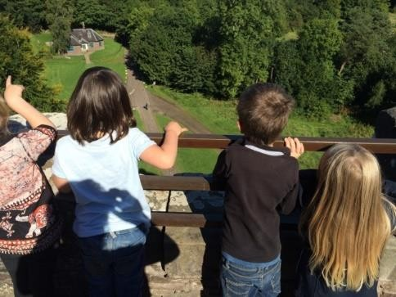
When we explained if there were no concerns about our newborn son or our family - which we were assured there were none - I explained we no longer required the optional service. The health visitor turned cold and explained she would have to document that I was refusing the engage with the service. It was said in a menacing way as if this would affect us negatively. I checked if the service we were "refusing to engage with" was "optional" and advised it was, so proceeded to withdraw us from further visits.

24% of survey respondents said they had sought advice on how to deal with over- reach by their health visitor (e.g. from a home education support network, advice organisation or lawyer), while 68% had not needed to and 8% had done so sometimes.
Contacted home education groups and got HE advice from individuals. Also read a great deal about the Named Person scheme.
I felt nervous about the health visitor’s keen interest to see my children and their reluctance for us to stop the visits. I felt like we were being monitored/assessed. I spoke with other home educators and they advised I opt out of the optional service.
I had to make the practice manager aware of HV behaviour, who arranged replacement. I also made a complaint to Midwifery council but went no further because of fear of payback from HV service. Found out later that HV could have been struck off for misconduct.

A number of home educators have submitted formal requests for data held on them by health visitors, which is now our forum’s standard advice to members.
On the subject of case notes and chronologies, 22% of respondents said that their health visitor had recorded inaccurate information or subjective opinion about their parenting decisions and educational choices, 22% said the records were accurate and 56% did not know.
Half of our records were completely false when we looked.
Totally subjective opinion of home education not being in child’s best interests (under school age) recorded in SHANARRI, total ignorance of different educational approaches and tick box mentality, no relationship building or willingness to listen. All evident from records which were of course shared willy nilly as “wellbeing concern”.
SAR was submitted, but not all information was provided.
I would be interested in seeing the information they have as I know that they documented the education "status" of my older home educated children.
I haven’t checked my records, but our HV was quite interested in home ed and didn’t particularly express any negative views around it

On the sharing of family members’ personal information, 41% of respondents said health visitors had done so without obtaining their consent (or via uninformed or coerced consent), 16% said their health visitor had not done so without consent and 43% did not know.
HV shared with Social Work and other organisations. Then lied about it knowing she could be caught out, which she was. We had her replacement advising of details that the predecessor allegedly hadn't told anyone.
Over and over, and knowingly so, even lied about it.
She shared information with the council, which was later used by Social Work and is now being used to inform other professionals’ reports. I was kept in the dark.
One of them did. We raised the roof. Huge apologies were made. No idea what else happened that we didn’t know about.
I felt like I didn't have enough information when I gave consent for data sharing when asked. In hindsight I wish I hadn't.

Of the 40% of respondents who had submitted subject access requests for their records, only 31% said their health visitors had processed them in compliance with GDPR, while 69% said they had not done so.
Asked whether their health visitors had offered accurate and impartial information and advice on their educational choices (e.g. the parameters of compulsory education age, the non-compulsory nature of participation in/registration for nursery or school education, or the equal legal status of home education), 68% said they had never done so, 9% said they had always done so, 3% said ‘sometimes’, and 20% did not know.
My health visitor plainly lied and told me home education was illegal, then switched to 'very complicated'.

We haven't discussed education choices, never came up.
She was constantly telling me I should place my child with a nursery.
My health visitor was not knowledgeable about these areas but was happy to go away and find out. Unfortunately, she was given inaccurate information from her superiors
I wasn’t considering home ed at that point, but certainly no one ever told me it was an option, I just thought nursery and then school at 3/4/5 was the only option.
We weren’t home educating at the time we had a HV, but she (one of them) was highly complimentary about a family nearby who do, and in fact put us in touch. Leads me to believe she’s supportive.

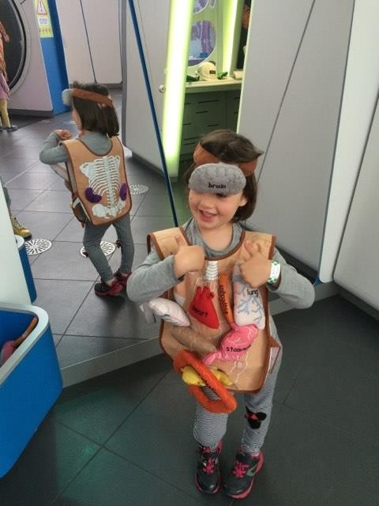
On health visitors’ understanding of the law and opt-in nature of services (including their own role, the named person scheme, nursery and school), 57% of respondents reported having to correct erroneous advice, while 43% had not needed (or felt unable) to do so.
Only because I was scared to explain. She assumed Named Person status while knowing it was scheduled to become law a month later. She assumed lots.
All the time, almost at every visit we had.
She thought it was illegal to home educate. As soon as I clarified it is legal, she became helpful.
I explained we didn't want a named person and was told by the child assessor of my child’s development test that that it wasn't optional.

We also asked if any health visitors had stated (or strongly implied) that declining optional universal services (e.g. health visiting, nursery, school, named person) represented a child welfare concern. 44% said yes, 44% said no and the remainder were not sure.
I have been referred to social work since declining further visits.
I was told I had an unseen child by my current health visitor when she knew my child has to see a collection of professionals because of being non-verbal and ASD.
The present HV presented it as somehow dubious that further visits weren't needed. She has always been very supportive of our approach and decisions
We never declined but when we tried to explain that we want to wait, we were sort of "suggested" to consider nursery anyway. I don't think child welfare was mentioned. We probably didn't argue enough for that to come up.
She stated our child was "unseen" and that we had refused the HV service and that this was a significant concern. They ignored our letter we had sent stating that whilst we had declined their offers of home visits and advice, we would approach them when or if we needed to.
Implied it would have negative consequences.

When it came to raising concerns about health visitors thought to have acted outwith the law and/or their professional code of conduct (e.g. with a GP practice, NHS board, MSP or lawyer), 30% had made complaints and 16% had considered doing so, while 54% had not complained.
I considered complaining to the manager of the GP practice and had complained to the Midwifery council about the first HV because of her conduct. The only reason I didn't go further was because we'd just moved into a new area and I didn't have enough. My child comes first.
I have not gone through with complaints through fear of payback, which has happened anyhow. The opposite of complaining, I have written to thank them for their care
Apparently the professional "left" before action could be taken.
The people I complained to were very helpful. They apologised for her. It's only now that I've been privy to her multi-agency meetings done without my knowledge while she would have known that she'd put us in a dangerous legal situation by discussing us so openly.
The GP offered a simple apology and it seemed half-hearted. Health visitor was openly annoyed as she was told it was us who complained
The HV couldn't see any problem, lied about her actions and caused more issues behind the scenes. I was thanked by the manager for not making a complaint because of the work it would involve. I believe that the manager had no idea what the HV was doing.
Denial!

The overwhelming majority of our survey respondents (78%) agreed that health visitors should receive ‘mandatory training in the law and guidance relating to home education and parental choice, delivered by those with appropriate expertise’. None disagreed and 22% were unsure.
100% agree.
They can’t be trained in everything but they should have access to accurate information
I think they should get their own house in order first. If they are furnished with too much information, they seem unable to cope. I also feel that information provided to professionals compromises their ideals and the very reasons for which they exist.
If it could earn Continuing Development Credits I feel this may be beneficial for all involved and an incentive for the nurses in their busy schedule.

Case studies

Besides the poll and smart survey, we also invited a few more detailed accounts of home educating parents’ dealings with health visitors.
L told us:
Our health visitor took it upon himself to put a report into social services after we told him, naively, that we were home educating our eldest (of school age). He then started harassing us, sending us letters telling us it was a prerequisite to register our daughter with the council and showing up at our door without calling first.

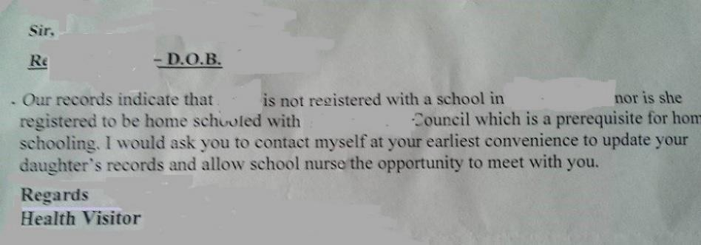

I came in from hanging out washing for my daughter to tell me a strange man was looking in our living room window and I spotted him sitting in his car watching the house. We then had social workers show up when we were out, who posted handwritten notes through our door on three occasions but nothing on official headed paper. We called them and recorded the conversation, which confirmed that our health visitor had lied in his report, saying "he sensed someone was home", that he "was asked to leave on one occasion" and that we were "refusing to engage".

Social work closed the case because they knew the referral was ridiculous and we had the head of the health visitor service out to our home to let her know how unhappy we were and that was an end to the matter. However, last year, we had another baby and opted out of the health visitor service, but received a letter from a new health visitor saying she would like to visit and asked us to get in touch (though acknowledging we had opted out). When we called to decline, our previous health visitor said he would pass the message on, but then a letter arrived from social workers saying that they had received a request from the Scottish Children's Reporter's Administration to complete a social background check because our child had not been seen by the health visitor. Although we should have first been invited to visit our GP, we had received no such letter. When the social worker came she told us she could not understand why the referral had been made and the case was again closed. She confided that the health visitor had first called social work and was told that our "case" did not meet the requirement for a visit, but she then proceeded (after reading the previous health visitor’s notes) to make a referral to the reporter in order to force social work involvement.

I am at breaking point and can't believe that we are still dealing with the fall-out from a malicious health visitor simply for declining an optional service! The social worker has had her time wasted, we have suffered yet more distress and anxiety, and the malicious allegations have not been deleted or corrected to avoid future issues arising. On receiving our records through SARs, we found disparaging references to our blinds being closed during the day (when my husband was working shifts and asleep) and on one of several unarranged visits, “people” were visible through the window (and ignored him knocking) when it was our five- year old playing as I was hanging washing. Not being registered at a school (or for “homeschooling”) was noted as a risk, as was “very poor engagement” with (allegedly optional) services. As a result of this harassment, I have zero confidence in health visitors. I will consult my GP if the need arises and have refused consent for any information sharing.

A told us:

After a health visitor refused to leave our family alone, to the point of stalking and harassment, we found through a subject access request that she had been agitating for a child protection referral based on the fact that we home educate our children and would not engage with her (optional, as we pointed out) service. We have three disabled children with a rare condition

who are regularly seen by specialists and we work happily with an excellent educational psychologist.

I withdrew consent to share any of our personal data after becoming concerned about obsessive behaviour by the health visitor and submitted SARs to all the agencies involved with my children. It required a court order to obtain my records from the council (unredacted due to the unannounced arrival of sheriff officers with the order) and they revealed secret multi- agency meetings with “do not tell mum” on notes that showed how my child’s former head teacher had tried to discredit me for home educating, lied about the law and colluded in sharing information to undermine my decisions. Records showed that only the educational psychologist had refused to disclose information without my consent. Others, including the health visitor, had actually shared my own and my children’s medical records with a teacher!

J told us:

I live in the east end of Glasgow and have had ongoing problems with health visitors who all object to my choices as a parent, especially home education, and have conspired with education to claim child protection risks and repeatedly refer us to social work. We do need a bigger house as we are overcrowded, but no one seems to be able help with that and our housing officer has been sent to snoop and report back as I have refused to allow a health visitor in my home.

My sensitive medical information, including details of a recently diagnosed condition, has been shared without my permission with ‘services’ outside the NHS who have used it to undermine me. One of my previous health visitors was struck off for fabricating records and when I obtained mine through SARs, I found a lot of inaccuracies including an alleged historical admission to a psychiatric unit that never happened, so the notes were either fabricated or mixed up with someone else’s. I feel victimised and live in constant fear of the next social work referral.

One of our members, who is legally qualified herself, provided affidavit evidence of her poor treatment by the health visiting service to the Supreme Court in 2016. She has summarised her experience for this report.
Approximately a year before my child reached Compulsory Education Age, his Health Visitor called me to say that she was going through his file and noticed that she had no school noted for him. I explained that my child was not of compulsory age until the following August and we were unsure, as yet, whether we wanted to Home Educate or register for a local school.
I thought that I wouldn't hear anything further; however, a few days later, I received another telephone call from the HV insisting upon a Home Visit to check on my child with no justification as to why (only that she had been told that she must conduct one). I asked for a letter requesting this Home Visit and the legal basis for the request. A letter was not sent by them but I did receive a call from a Team Manager insisting on visiting my home to discuss my concerns. I refused this request as my sole concern, from the outset, was the insistence on visiting my home with no justification as to why this was necessary.
After submitting a written complaint to the NHS board, it was brought to my attention that my son's HV wasn't "just going through his file" but had been party to conversations between her management and the Local Authority about my child's "wellbeing" and education. These conversations took place without my knowledge or consent and the HV had, at no point in my conversations with her, informed me of these exchanges.

As a result, I felt it necessary to contact the Patient Affairs Manager to explain my concerns. After investigation by an NHS Director, I received apologies for the conduct of his employees and recognition that I should never have been placed in such a position as we were a “good” family and there were no concerns whatsoever about the welfare or wellbeing of our children.
It was evident throughout my conversations with the NHS and my Local Authority that they were acting on the basis of the Child and Young Person (Scotland) Act that had yet to come into force. Evidence of my experience was later submitted to the Supreme Court and cited by counsel at the hearing of the ‘named person’ case.
From a personal perspective, I no longer have trust in my HV service and so opt to access any services I require directly, rather than seek their support in the first instance.

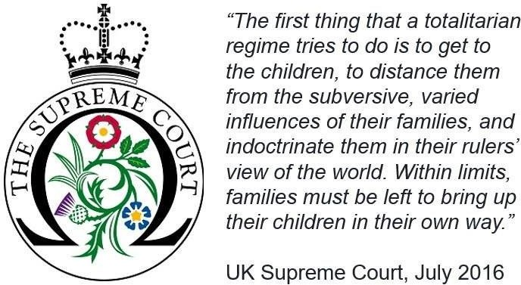

GIRFEC-experienced home-educating professionals

A significant number of GIRFEC-experienced professionals who home educate their own children, or were home educated themselves, are members of our forum, including a practising health visitor, doctor, lawyer, midwife, nursery nurses, teachers, social workers, counsellors, a psychologist, speech and language therapist, children’s panel member and several independent advocates. They are often able to support fellow home educators who raise issues that are relevant to their own areas of professional expertise and experience.
A health visitor and longstanding forum member, who home educated her own children in Scotland, shared her ‘insider’ perspective, offering a useful suggestion of specialist points of contact and advice within health visiting teams, rather than the ‘box-tickers with biases’ that have emerged via the named person scheme.
It is interesting seeing a different view now that I'm in England. From a health visitor perspective, I like the framework that GIRFEC gives you for the purpose of assessment as it does give you a holistic view of a family and their needs, which has always been our role, but what is severely lacking is any sort of understanding of home education. On my caseload, for example, I had a family who had been designated ‘additional needs’ purely because they home educated and when I met the family, I moved them to my normal caseload. There is a deep lack of understanding of home ed and an almost universal lack of understanding of the

law. My experience is that, although there is a mixed response from HVs, the response from social workers is much more negative. In my HV roles, both in Scotland and in England, I've put myself forward and offered to be an advisor/ liaison link person, but have never been taken up on it. There is a strong emphasis on the need for all assessments to be based on observed facts, but part of the problem is that professionals are not recognising their own biases based on their own experiences and lack of knowledge of alternatives to mainstream educational approaches.

A home-educating social worker commented:
It becomes very emotive when child protection is at stake, but that's precisely the point. It is no longer about child protection, but about the state determined ‘wellbeing’ of every child. If the professionals put in charge of data sharing and judging wellbeing have previously been primarily in contact with vulnerable children and “dysfunctional” families, their perception will be distorted and their default assumptions and gauge of ‘normal’ may be different to those who primarily come in to contact with the general public. It becomes a big block to free and open discussion. Any rational argument is shot down as an attack on preventing harm or "what do you have to hide?".

Summary and recommendations

Although there is undoubtedly some exemplary practice within the health visiting service in Scotland, our findings will nevertheless make uncomfortable reading for practitioners and their representative and regulatory bodies. They will also send a strong message to the government that a main plank of its GIRFEC policy is categorically not working for a significant number of home educators, who, as responsables for the care and wellbeing of their children, favour child- and family-centred learning over often-inflexible institutional settings.
Home educators are exercising an equally valid choice enshrined in law and feel stigmatised by references to ‘unseen children’ and ‘hostile, non- engaging parents’ which have been used by health
visitors and fellow professionals to ‘other’ our minority community. This baked-in bias has contributed to the hostile environment described by our members and is, we believe, at least partly responsible for incidences of ‘home-eduphobia’ (hateful conduct towards home educated children and their families), often by those who should know better.
A change in attitude from support to spying on the part of ‘SHANARRI-worshipping’ health visitors has been articulated by several parents with children of different ages. The more experienced parents felt more able to exercise their rights and challenge misinformation and assumptions, whereas the intrusive questioning and data sharing at the core of the GIRFEC policy (implemented exclusively by ‘optional’ health visitors

in the early years) has caused some less experienced parents to feel threatened and fearful of adverse consequences if they do not comply with ‘desired’ state-dictated outcomes.
The ‘E’ in GIRFEC means that services should be offered universally, consistently and objectively to every child and family by suitably qualified professionals; and crucially, the provision of information and advice should not stray beyond a practitioner’s own area of competence, or give rise to ‘confirmation bias’, whether working solo or in collaboration with other agencies. Box-ticking and profiling children and their parents with crude ‘wellbeing’ tools that demand the disclosure of unrelated sensitive personal data for uncontrolled ‘joining-up’ is seen as an unacceptable intrusion into family life and has dented confidence in universal services. As one parent put it, “the GIRFEC rot runs through services like a stick of rock”, with minority groups invariably targeted for ‘remediation’.
Throughout our research, issues around informed consent and choice were frequently highlighted by parents. They are suffering the consequences of the government’s failure to take remedial legislative action after Parts 4 (named person scheme) and 5 (child’s plans) were struck from the 2014 Children & Young People (Scotland) Act in the wake of the Supreme Court judgment, which prohibited information sharing on the basis of ‘vague’ and subjective wellbeing concerns. The government’s attempt to pass a new bill remains stalled at stage 2 of the parliamentary process in anticipation of a long-awaited, binding code of practice that is able satisfy the terms of the court ruling, as well as overarching human rights and data protection legislation.
Meanwhile, GIRFEC practitioners, a large number of whom are health visitors and teachers, have been left in limbo by long delays in clarifying the rules around information gathering and sharing, and the legal bases that permit such processing without consent. NHS and other public sector policies, including the 2014 national child protection guidance, are still relying on the (wrong) threshold of ‘wellbeing’ to override consent, citing ICO guidance from 2013 that had to be withdrawn in 2016.

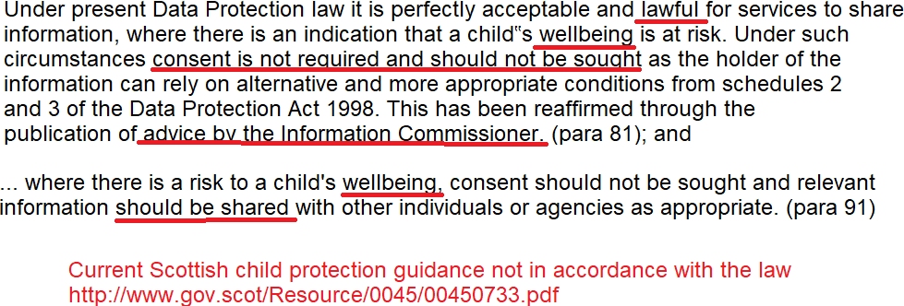

Many are also using dubious definitions of ‘voluntary’ arrangements that are far from consent-based and essentially amount to coercion, giving rise to ethical questions. When one professional was challenged by a parent’s advocate on the lawfulness of re-defining a ‘voluntary’ agreement as de facto compulsory, the response was simply, “I know, but it’s how we work”.

As the Supreme Court affirmed, these are all serious human rights issues, which need to be addressed urgently as reports of ultra vires activities are escalating in parallel with the rising number of home educating families, the reasons for which we analysed and reported in our 2018 survey.
On a positive note the NMC’s own code seeks to strike the right balance, being underpinned by long-established principles of consent, respect and confidentiality. It should rightfully take precedence over the blanket, outcomes-driven GIRFEC policy that relies on an undefined notion of ‘wellbeing’ to interfere in families’ lives without their consent. The much-mooted ‘shared understanding’, which assumes universal agreement with state-defined outcomes, has remained elusive, yet has put non- mainstream and minority communities at greater risk of stigmatisation ‘on the spin of a SHANARRI wheel’.
The National Health Visiting Core Service Specification for 2015-16 (NHS England, 2014) stressed that the delivery of health visiting services should be informed by user experiences and feedback from families. Flexibility should surely be at the heart of person-centred services such as health visiting, but this appears to have been overridden by GIRFEC-dictated ‘pathways’. As one parent told us:
I would like the option to engage with the service at a clinic, not in my home. I was advised because the HV has no clinic, only an office, this was not a possibility, I would feel uncomfortable having the HV in my home now that the role has been expanded to collecting (and sharing) family information that is not directly related to my child’s health and development.

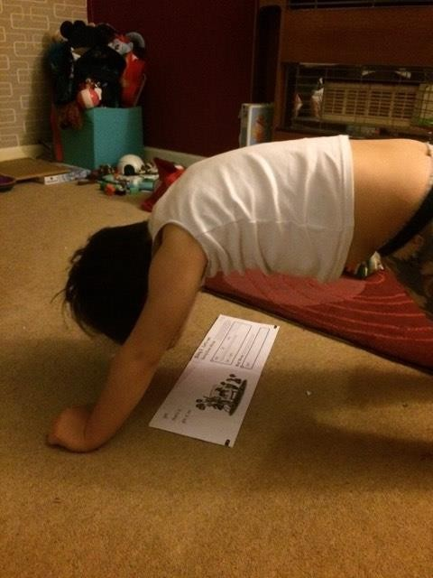
The re-building of respectful relationships will be a prerequisite if mutual trust is to be re-established between home educators and health visitors, and we are hopeful that, by pointing out some of the issues that have arisen for our community, the process can now begin in earnest. Unless the problems are addressed, home educators’ engagement with health visiting services is likely to decline, which will inevitably lead to further conflict and complaints.
We acknowledge that many of these problems are not of health visitors’ own making and lie at the door of government. They have simply been swept along with the GIRFEC policy tide that has sent them perilously close to the jagged rocks of GDPR and human rights.
Home educators should have been properly consulted, with comprehensive impact assessments undertaken on policies that affect them, especially when they are to be implemented by practitioners whose knowledge of pertinent legislation is limited or non-existent. Home educating and autonomous parenting communities are always overlooked and their needs ignored, despite being more likely to belong to groups with protected characteristics under the Equality Act (including disability, race, religion and philosophical belief), and the growing evidence base of their having experienced discrimination. Intentional exclusion from evidence sessions during legislative scrutiny

and committee inquiries, and the consistent refusal of ‘regulators’ to investigate infringements of the rights of home educated children and their families (a point we highlighted in our joint parliamentary petition), has only served to confirm the deep- rooted anti-home education bias that has contributed to the stigmatisation of our law- abiding minority community.
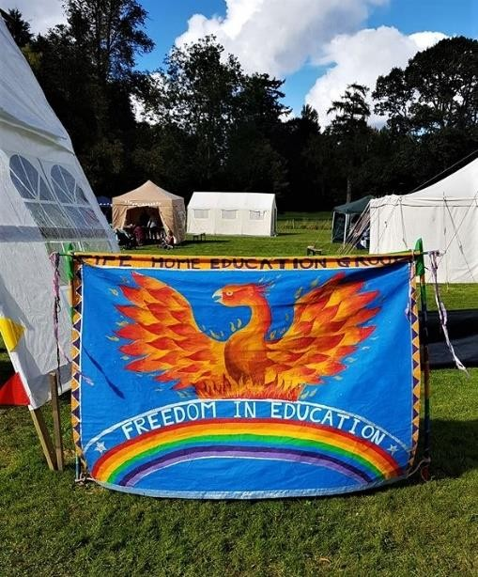
We have incidentally also been made aware by parents ineligible to complete our survey that the problems we have highlighted with health visitors are not confined to the home educating community as many ‘mainstream’ families say they are also being poorly served by this universal, allegedly optional, service.
Our forum representatives have been invited to speak to practitioner teams on an ad hoc basis, but no formal arrangements are in place to ensure universal services are equipped with a universal understanding of home education issues. An experienced home educating health visitor has also highlighted the inconsistent practice in the
profession and suggested that visitors with specialist knowledge and additional training could advise teams on home education ‘cases’, rather than automatically dumping them into ‘unseen’, ‘non-engaging’ or ‘additional needs’ categories.
In an effort to progress this, we have twice met with the Scottish Government and stressed the need for dedicated training in relation to home education for health visitors and all family-facing GIRFEC professionals, for which agreement in principle was secured, albeit with no indication of a timescale. Given our survey findings, we now consider this to be a most pressing priority and would welcome support from health visitors and their professional body in bringing our recommendations to fruition.
Our thanks go to all the parents who took time to complete our poll and survey and to those who offered more detailed accounts of their experiences and insights, not forgetting the home educated children whose photographs we have included, with permission, to illustrate some of their everyday activities. We sincerely hope our report will be a useful contribution towards making the necessary improvements to policy and practice within health visiting, and indeed wider universal services, to better serve the needs of children and families in Scotland.

© Scottish Home Education Forum, June 2019

