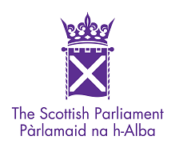
Education and SKILLS Committee

Alison Preuss  By email | T3.40  The Scottish Parliament  Edinburgh  EH99 1SP  Direct Tel: 0131 348 5222  Fax: 0131 348 5600
 | es.committee@parliament.scot
 | 14 December 2017
Dear Ms Preuss

Firstly it was very nice to meet with you and others a few weeks ago, thank you for taking the time after a long day at your event to meet me and present the evidence you have gathered.

The Committee has considered your submissions, including all the postcards, in a formal Committee meeting and has now published your submissions online.

After consideration of the evidence that the committee heard and received in writing the committee has decided that no further work on the Children and Young People (Information Sharing) (Scotland) Bill will be undertaken until towards the end of next year to enable the Committee to scrutinise the Code of Practice that would accompany the bill. Please find attached a letter sent to the Cabinet Secretary for Education on the 7th December detailing the Committees considerations at this point.

In relation to your request for a public inquiry, please note that the Committee has not given specific consideration to the issue you raise. The Committee has specifically focused on the proposed changes in the Children and Young People (Information Sharing) (Scotland) Bill, not existing data sharing provisions (which are soon subject to change under GDPR). The Committee has considered what the changes proposed in the Bill would bring to the current practice, including its effects on children, families and practitioners such as health visitors and teachers. Accordingly the Committee cannot comment on the request for an inquiry as it does not have a collective position on this matter.

Please note that this does not preclude individual members responding to your letter but they would need to respond to you direct in an individual capacity. You can find the contact details for individual MSPs on the Parliament website at http://www.scottish.parliament.uk/msps.aspx and the details of the members of the Education and Skills Committee can be found on http://www.scottish.parliament.uk/parliamentarybusiness/CurrentCommittees/education-committee.aspx

Should you have any further questions please do not hesitate to contact me or the Clerk to the Committee.

Yours sincerely
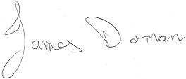
JAMES DORNAN MSP
CONVENER

